# Why You Have to Wait a Little Bit Before Do Jump Starter

A jump start is a life-savior moment if you’re in a long road run and suddenly having a down battery. Batteries often run out of charges due to their old age and connection loss. So, to regain the apt charge for starting the engine it takes 10-15 minutes.

## The battery takes time to jump start

A battery simply doesn’t take long to have a jump start. Some very crucial and trivial aspects might take forever to jump start. The following section covers that.

### Dirt on my battery

Firstly, your battery can be greasy and dirty enough to not accept the proper charge amount. Here one thing that is very important to note down is the oily texture if you have on your battery surface. This can lead to a massive explosion.

Greasy batteries are not suitable for clamp charging. The jump start draws out a very high amp for the battery and so, the spilled oily environment can be very dangerous. Other than that, the dirt piles of the battery area can take time to load up the charges.

### Terminal Dirt

The clamps are always attached to the terminals of the positive and negative sides of the battery. So, if the terminals are clogged with any piece of debris, this can lead you to a good amount of time. It is always recommended to keep them clean or keep a brush to dirt them off.

### Old battery

If the battery is pretty much beyond repair then this can take a lot of charges but yet will not start. In this specific case, you’ll know how old your car battery is; usually, a battery runs fine for 2-4 years approximately.

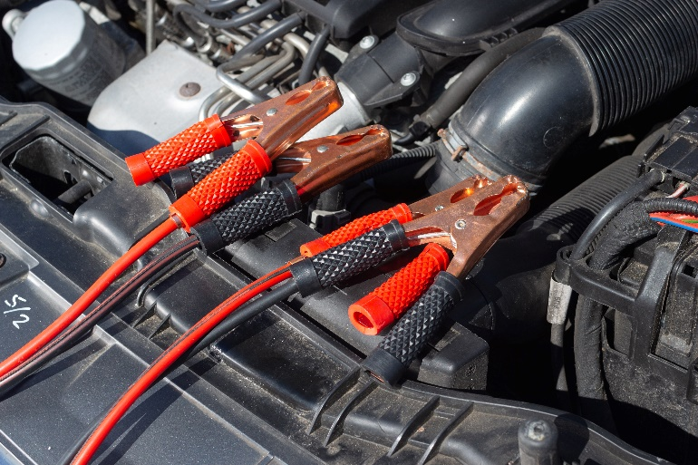

### Fluid check

Often the jump start takes extra time to recharge for not having efficient fluid in the containers of the battery. So, it is also a very important part to check the liquids. Else this can overheat the system and might hamper the battery as well.

### Temperature

In a colder season or region, the battery usually doesn’t pay heed to the kickstart. The way is to take your car somehow to a warm place where the cold can barely strike and reinitialize the process.

### Mis-adjustment of the clamps

Firstly, the red clamp is connected with the dead battery's positive side and the other red one is connected to the other car's battery or the starter. Secondly, connect the black clamp to the starter, and the other part of the clamp is joined to a bolt or grounding. Then the jump start starts working from the other car's battery or starter.

However, this procedure of connecting the proper clamps to the adjacent terminal is needed to be done accordingly, else you’ll not get any charge at all or might go for an explosive event even. After the dead battery is juiced up again then unplug the clamps in reverse order; remove black parts and accordingly the red parts.

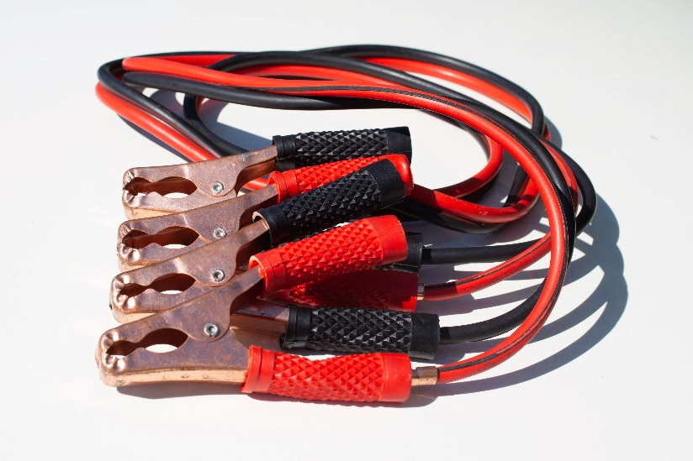

## The period for the boost

If you simply blaze up with just after aligning the clamps, simply remove it in reverse order and don’t let it keep on charging. Usual cases say, the jump start takes at best 15 minutes, and sometimes it can take up to 30 minutes if the battery is too old. If it is still not working you know you need a change.

## Dead battery refill

Technically, the jump-start method was not destined to restart a completely dead battery. However, often a kickstart from the jump can restore the charges and thus you get to run your car. But general cases, it is not what a jump start is designed for.

FAQ

In what manner should I connect the clamps?

Firstly, connect the positive ones (red) and then the black or negative ones. While removing the clamps, make sure you maintain the reverse trial, removing the negative and then positive.

How do I know if the battery is charged enough?

When connecting the clamps make sure your car is in halt mode. After the connection is set and it got enough charge transferred, try making the key start the car. If your car dims the front light that indicates the work has been done properly.

How long will jump-start work?

A couple of years maybe. Jumpstarts can simply give the go for your battery and keep it running for a long time.

Does jump-start hamper the battery life?

Jump starts from another car battery is often not a good idea, as you don’t to what extent power is drawn. In that case, the car that is lending power can even damage the battery and explode even.

## Conclusion

Jumpstarts to take time to give the push to the battery due to the transferring of the minimal charge to run it off. Most often this rev-up mechanism finishes the job in 5 mins and you are good to go. But it is always recommended to keep the clamps along with you. And if possible, keep a good powered starter as well.